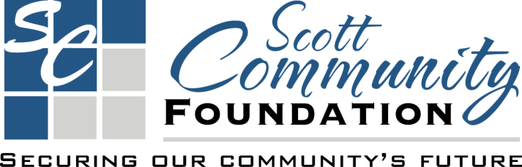
Giving Day Participation Contract
Name of Organization: __________________________________________________________
Fund: _________________________________________________________________________
Contact Person: _______________________________________________________________
Phone: ___________________________________Email: ______________________________
______ YES, we will participate in the Scott Community Foundation Giving Day on Tuesday, November 15, 2022, upon the following terms.
- Agree to fully participate in the Scott Community Foundation Giving Day.
- Contact and solicit current and prospective donors to attempt to obtain gifts on Giving Day, November 15, 2022 through Scott Community Foundation.
- Make knowledgeable representatives available for media contacts and opportunities to promote Scott Community Foundation Giving Day.
- All bonus money on Giving Day will be determined at later time. Please see the Bonus Money Rule form for ALL of the bonus money guidelines and rules.
A) By signing below, Scott Community Foundation accepts and approves non-profit to participate in Scott Community Foundation Giving Day on the above terms.
B) By signing below, nonprofit agrees to participate in Scott Community Foundation Giving Day in accord with the above terms and such additional procedures, rules, and protocols as Scott Community Foundation may reasonably prescribe.
C) Must have contract signed contract prior to Giving Day. If you have any questions or concerns, please contact by October 14.
________________________________________ ________________________________
Board President or Executive Director Signature (Non-profit) Date

________________________________________ ________________________________
Executive Director Scott Community Foundation Date

Submit completed form to leslee@scottcf.org or mail to
Scott Community Foundation, 210 W. 4th St, Scott City, KS 67871
by October 14.

